# The Company - H. T. Borstensonwerke S.A

Author: [d.green@borstenson.com](mailto:d.green@borstenson.com)

## Company History

Borstensonwerke S.A. (Vaduz Liechtenstein) is a company manufacturing, importing and exporting brush products world-wide. We have a vast knowledge expanding over 40 years of supplying and manufacturing brushware and allied products worldwide. We supply to a wide market including, wholesale and retail outlets, well known supermarket chains, builders merchants, buying chains, janitorial supplies purchasing groups, and large DIY Groups.

Our customers include many household names, large retail outlets, and wholesale distribution centers. We specialize in supplying high quality brushware to the trade

Brushware manufacture and distribute brushes throughout the Liechtenstein and across Europe. We are proud to be one of the few Brush Manufacturers still based in the Liechtenstein. Why not call us today and find out why our customers use brooms and brushes of the Bürstenfabrik Horst Thorsten Borstenson.

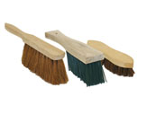 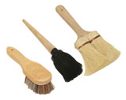 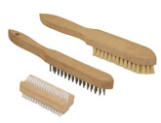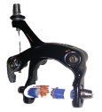

## The founder: Horst-Thorsten Borstenson

Horst-Thorsten Borstenson founded the company 1994 in St. Gallen in Switzerland. He started with the production of wooden brooms and brushes. In 1999 he moved the headquarters to Vaduz in Liechtenstein. Today he is still the CEO of the Borstensonwerke S.A. in Liechtenstein.

Today the company has branches in Germany, Singapore, Cayman Islands, Luxemburg and the US (Delaware).

Horst-Thorsten Borstenson also called “Father Horst” by his employees, has over 1000 patents in the broom and brushes area.

He is awarded the honorary doctorate of the Berkeley University of California for his contributions to the technical advancement of broom technologies. “Dr. h. c. Borstenson has done a lot for the development of a dust-free world”.

In addition to his industrial activities, Dr. Borstenson is also active in the field of sports promotion. He runs the professional cycling team “Rakete Frankfurt”. This team achieves an excellent 18 place at the World-Klapp Race in Germany in 2016.

You can reach him under:

Email: [ht@borstenson.com](mailto:ht@borstenson.com)  
mobile +432 1551 877254

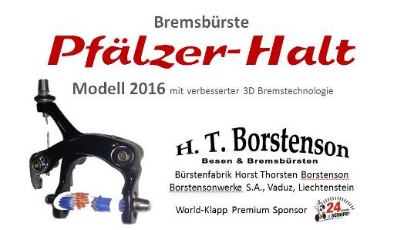

**Product of the year 2016:**

BOP.214.17419 Break-brush “Pfälzer-Halt” advanced 3D

Borstenson actively engages in cycling and acts as a sponsor of famous cycling races

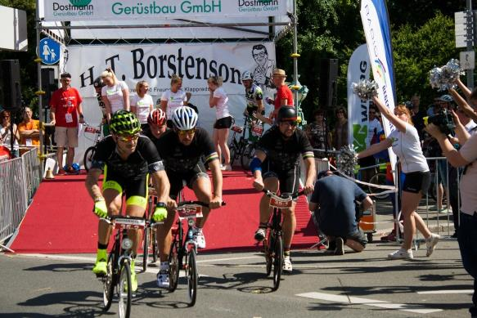

Borstensonwerke S.A. – Bürstenfabrik Horst Thorsten Borstenson, Vaduz, Liechtenstein